Digital Video Processing
Homework #1, Oct. 31, 2006, Due: Nov. 20, 2006

Note: all the following assignments should be implemented in C or Matlab programming languages (you may use Matlab or Excel for showing the pictures). Each team only needs to hand in one homework report. You have to hand in the results (should be typed in the Word format) and all the codes (with comments) and executables (zipped in a single file) to the TA (蔡佳銘 tcm92@cs.ccu.edu.tw).

1. Download the “Lena” image file (128x128, .bmp format) on the class homepage (http://www.cs.ccu.edu.tw/~cwlin/courses/vsp/homework.htm).

- Compute the occurrence probability of each pixel value (0-255), show the histogram and compute the entropy.
- Use the following predictive coder which uses the either of the left and upper pixel values as a prediction, then send the prediction error (X-X’). If all the left and right reference pixels (A and C) are not available, the prediction is set to zero. If only one of the reference pixels is unavailable, use the available reference pixel value as the prediction. Compute the occurrence probability of each difference pixel value (-255~255), show the histogram and compute the entropy.
B
A
X
X’ = C if ⎪A-B⎪< ⎪B-C⎪
X’ = A if ⎪A-B⎪≥ ⎪B-C⎪

C
- For the difference image in (b), write a program to construct a Huffman code and encode the image. In constructing the Huffman code, sort the occurrence probabilities, then group those 480 symbols with probabilities less than the first 31 highest ones’ to form a new symbol (ESCAPE symbol). Design a Huffman table for the 31 highest-probability symbols and the ESCAPE symbol. Append a 9-bit fixed-length code to the ESCAPE symbol to distinguish the low-probability symbols. Show the VLC codeword table for the 31 highest probability symbols + the ESCAPE symbol.
- What’s the compression ratio? Compare it with the Winzip or Winrar tool.

2. Write a code to generate an N-bit Max-Lloyd midrizer quantizer (Assume the input range is normalized to -1~+1) for Gaussian distributed sources, show the result for N = 6.

3. 2-D NxN DCT is defined as:

where $C(u),C(v)=1/{\sqrt{2}}$ for $u,v=0$ and $C(u),C(v)=1$ otherwise.

- Divide the “Lena” image into NxN blocks (N = 8, 16, 32), then apply the NxN DCT on each pixel block to get its DCT coefficients.

(b) In addition to the DC coefficient, only keep N/4xN/4, N/2xN/2, and 3N/4x3N/4 lowest frequency coefficients and set all other coefficients to zero, and then perform the NxN inverse DCT.

- Compute the mean square error (MSE) in the pixel-domain:
MSE =
- Generate three figures similar to the example shown below (with DCT only) for the cases retaining N/4xN/4, N/2xN/2, and 3N/4x3N/4 low-frequency coefficients, respectively.

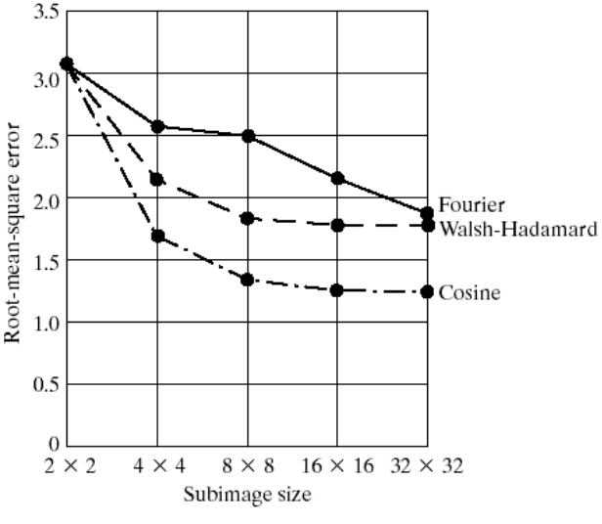
(c) Show the reconstructed image with retaining N/4xN/4, N/2xN/2, and 3N/4x3N/4 low-frequency coefficients for N = 8 and N = 16(if the reconstructed pixel values are greater than 255 or smaller than 0; you need to clip the values to be in this range)

You can download the image display tools from the class homepage (The zipped files including ImPlayer.exe and ImPlayer.reg) to view the monochrome and color raw image/video

  - Run ImPlayer, and use the “File” option to select the file as follows:

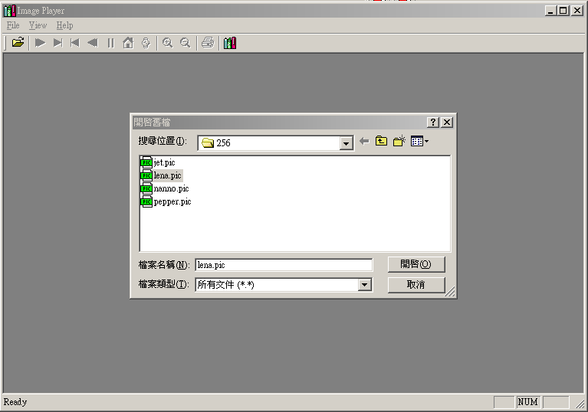

  - After choosing the file, set up the video configuration as follow:

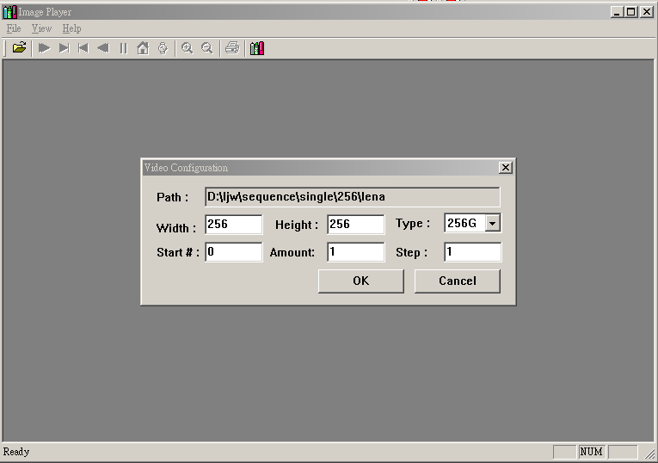

  - Finally you can view the image as shown below.

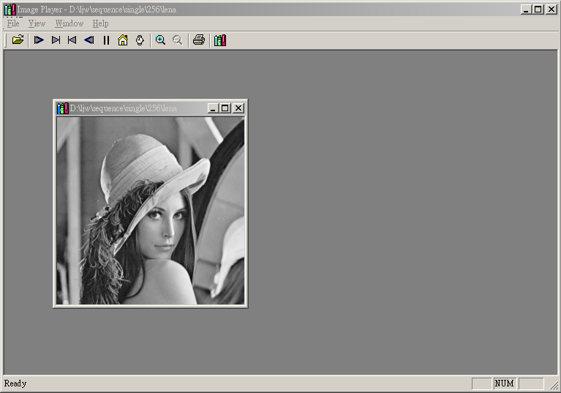

Please keep the software for future’s assignments.

