Video Coding & Communications
Homework #1 Part2, 10/29/02, Due: 11/20/02 (Sunday)

Note: all the following assignments should be implemented in C or Matlab programming languages (you may use Matlab or Excel for showing the pictures). You have to hand in the results (should be typed in Word format) and all the codes (zipped in a single file) to the TA (李育瑞 lyj@cs.ccu.edu.tw).

1. Download the “Lena” image file (128x128, .bmp format) on the class homepage (http://www.cs.ccu.edu.tw/~cwlin/courses/vcoding/homework.htm).

- Compute the occurrence probability of each pixel value (0-255), show the histogram and compute the entropy.
- Use the first-order predictive coder which uses the average of the left and upper pixel values as a prediction, then send the prediction error. If the value of A or B is not available, it’s set to zero. Compute the occurrence probability of each difference pixel value (-255~255), show the histogram and compute the entropy.
A
B
X
X = int ((A+B)/2)
- For the difference image in (b), write a program to construct a Huffman code and encode the image. In constructing the Huffman code, sort the occurrence probabilities, then group those 496 symbols with probabilities less than the first 15 highest ones’ to form a new symbol (ESCAPE symbol). Design a Huffman table for the 15 highest-probability symbols and the ESCAPE symbol. Append a 9-bit fixed-length code to the ESCAPE symbol to distinguish the low-probability symbols. Show the VLC codeword table for the 15 highest probability symbols + the ESCAPE symbol.
- What’s the compression ratio? Compare it with the Winzip tool.

2. 2-D 8x8 DCT is defined as:

$$F(u,v)=\frac{1}{4}C(u)C(v)\sum_{m=0}^{7}{\sum_{n=0}^{7}{f}(m,n)\text{cos}(\frac{(2m+1)uπ}{\text{16}})}\text{cos}(\frac{(2n+1)vπ}{\text{16}})$$
$$f(m,n)=\frac{1}{4}\sum_{u=0}^{7}{\sum_{v=0}^{7}{C(u)C(v)F}(u,v)\text{cos}(\frac{(2m+1)uπ}{\text{16}})}\text{cos}(\frac{(2n+1)vπ}{\text{16}})$$

where $C(u),C(v)=1/{\sqrt{2}}$ for $u,v=0$ and $C(u),C(v)=1$ otherwise.

- Divide the “Lena” image into 8x8 blocks, then apply the 8x8 DCT on each pixel block to get its DCT coefficients.

(b) In addition to the DC coefficient, only keep three most significant DCT AC coefficients (the three AC coefficients with the largest absolute magnitudes) and set all other coefficients to zero, and then perform the 8x8 inverse DCT.

- Display the reconstructed image (if the reconstructed pixel values are greater than 255 or smaller than 0; you need to clip the values to be in this range)

- Find the mean square error (MSE) in the pixel-domain:
MSE =

(c) In addition to the DC coefficient, only keep 7, 11, 15, and 19 most significant AC coefficients and repeat (b) (find out MSE, and display the reconstructed image). Plot the MSE and PSNR figures (versus the number of non-dropped coefficients).

(d) Perform quantization on DCT coefficients in (a) using a uniform quantizer with a quantization step-size of 2Δas shown below (rounding is used after dividing by the quantization step-size)

then perform the inverse DCT.
For Δ= 5, 8, 11, 14, 17, 20, show the reconstructed images and plot the MSE and PSNR figures.

3. For the two consecutive 360x240 luminance raw images (pong1.y and pong2.y), divide the images into 8x8 blocks, then implement the following motion estimation algorithms with a search range of -7~+7 pixels in both directions and the Sum of Absolute Difference (SAD): Full Search Algorithm (FSA) and Three-Step Search (TSS).
(a) Show the error images after motion compensated prediction, and compare the MSE values of the error image
(b) Apply the 8x8 DCT transforms on the error images, then quantize the DCT coefficients of error images using the quantizer in 2(d) with Δ= 8 and 14. Add the reconstructed (dequnantized and inverse DCT transformed) error images to the motion-compensated reference images from pong1.y (with FSA and TSS) to obtain the reconstructed image of pong2.y, then show the reconstructed images and the associated PSNR values.
You can download the image display tools from the class homepage (The zipped files including ImPlayer.exe and ImPlayer.reg) to view the monochrome and color raw image/video (this tool is provided by Dr. Yao-Jen Chang at Dept. EE, NTHU)

  - Run ImPlayer, and use the “File” option to select the file as follows:

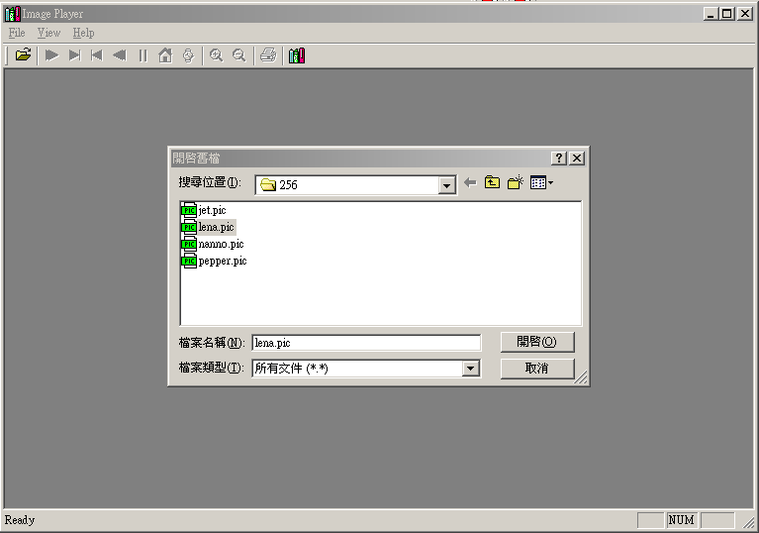

  - After choosing the file, set up the video configuration as follow:

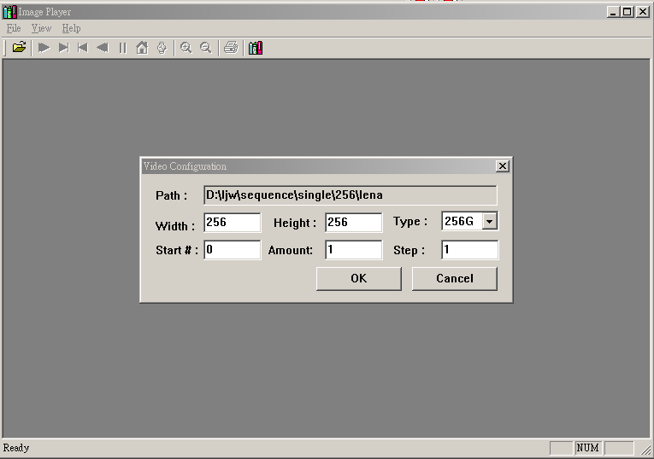

  - Finally you can view the image as shown below.

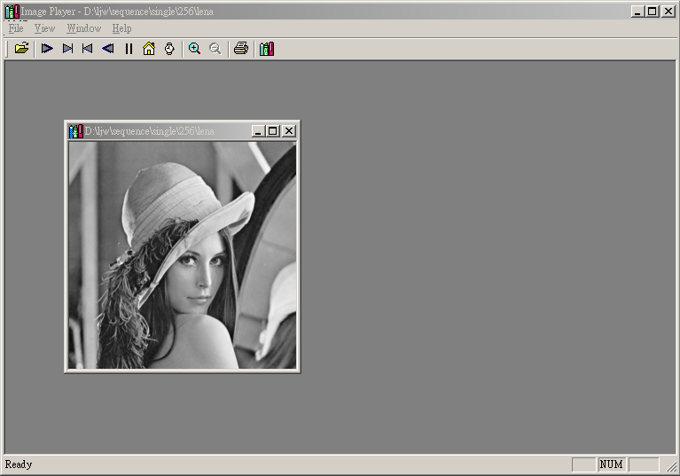

Please keep the software for future’s assignments.

