Video Coding & Communications
Homework #1 Part1, 10/29/02, Due: 11/10/02 (Sunday)

Note: Please hand in the results (cane be hand-written or typed) to the TA (李育瑞 lyj@cs.ccu.edu.tw, Lab 308, ext. 23126) before the deadline. No late homework will be accepted!

- Arithmetic Coding. (20%) Encode and decode the following sequence using arithmetic coding. And show the bit rate of the coded sequence.
a c b a a b a c a c b a
- Use the occurrence frequency of each symbol in the sequence as the estimate of the probability of the symbol? (10%)
<Ans.>
假設傳輸coded sequence需要時間 t sec, 且x是要傳輸的數字， x∈ [l, u)，l=0.4422454833984375, u= 0.442249298095703125. 只取x的小數點以下六位數字當作整數來傳輸，0.442245 <= x < 0.442249。因為 2^19 > 442249，所以使用19 bits 傳輸。再加上傳輸p(a), p(b), p(c)各使用8bits，則 bit rate=43/t bps。

- Use the adaptive arithmetic coding scheme that updates the probability model according to the incoming symbols? (10%)
x∈ [l, u)，l=0.2847562622562622…, u= 0.2847568568997140…，只取x的小數點以下七位數字當作整數來傳輸，0. 2847562 <= x < 0. 2847568。因為 2^22 > 2847568，所以使用21 bits 傳輸。再加上傳輸p(a), p(b), p(c)只使用8bits，則 bit rate=29/t bps。■

- Quantization. (15%) As shown below, with a (2N+1)-level uniform midtreader quantizer, determine the mean square error for an input source with a dynamic range of –A~+A and the illustrated probability distribution.

-A
A
0
p(X)
X
Probability Distribution of X

Q
X
Y

<Ans.>

■

- JPEG. (15%) In a JPEG encoder, after DCT and quantization, the block is:

-14 0 -4 0 0 0 0 0
0 -1 0 0 0 0 0 0
0 0 0 0 0 0 0 0
2 0 0 0 0 0 0 0
0 0 0 0 0 0 0 0
0 0 0 0 0 0 0 0
0 0 0 0 0 0 0 0
0 0 0 0 0 0 0 0

Assuming the DC value of the previous block is –9, what is the resultant coded bit-stream?
<Ans.>
After zigzag scan: -14, 0, 0, 0, -1, -4, 0, 0, 0, 2, EOB.
DC: DIFF = DC_{i} – DC_{i-1} = -14 – (-9) = -5 ,
then CAT = 3. From Table-DC of Appendix B, the code-word is 100.
Append-Bits:
DIFF = -5 < 0, then DIFF – 1 = -6. Its binary representation is 1111…1010,
the low order bits are 010.
Thus the code-word become 100010.

AC: 0, 0, 0, -1, -4, 0, 0, 0, 2, EOB 其Code Word 為 (Run, Cat) Append-bits
Run-length event : (3, -1), (0, -4), (3, 2), (0, 0)
(Run, Cat)-Append-bits: (3, 1)-0, (0, 3)-011, (3, 2)-10, (0, 0)
Append-bits算法同上面的DC的算法
From Table-AC of Appendix B,
(3,1): 111010 (0, 3): 100
(3, 2): 111110111 (0, 0) (EOB): 1010
AC係數之code-word為:
1110100 100011 11111011110 1010

整段DC和AC的code-wword為:
100010 1110100 100011 11111011110 1010 ■

- Motion Estimation. (15%) With a search range of –w~+w at both directions, show the following motion estimation methods lead to the listed maximum number of search points.

Algorithm | Max number of search points
FSA | (2w+1)²
2D-Log | 2+7log₂w
TSS | 1+8log₂w
CSA | 5+4 log₂w

<Ans.>
FSA:
搜尋search window中所有的點。Search window的範圍在 x- 和 y-軸方向各為 [–w, w]，因此共需作(2w+1)²次搜尋(Block Matching)。

2D-Log:
一開始搜尋五個位置，一點在search window的中心位置，其他四點分別在 (w/2,0), (0, w/2), (-w/2,0), (0, -w/2) 的位置。第二次搜尋時step size不變，新增加三個搜尋位置。然後將step size 變為原來的一半 (w/4)繼續上述的步驟直到step size為1的之前一次搜尋為止。最後，檢查周圍及所在的位置共八點。每兩個連續的搜尋步驟需要4+3次計算(不包含第一次計算的中心點)，假設總共有n次”兩個連續搜尋”使step size到達2，w/2^{n}=2, n=log₂w -1。總共的計算次數為
1+7(log₂w -1)+8 = 2+7 log₂w.

TSS:
如圖，除了第一次多搜尋一個點(中心點)之外，每次step都搜尋八個點 (±w/2, ±w/2)，又每次step size縮小一半，直到step size為1的步驟完成搜尋。因此共需log₂W次搜尋，故一共為1+8log₂W次搜尋。
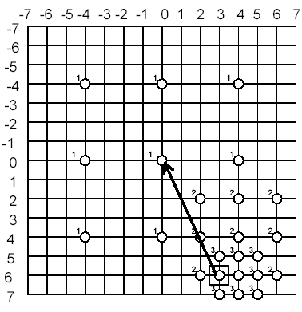

CSA:
如下圖，除了第一次多搜尋一個點，其他每次都是搜尋四個點，最後一次找到最佳的點之後，還多找了四個點(一最後一次找到最佳的點是在中間還是四週而定)，而因為和TSS一樣每次step縮小一半因此共需log₂W次搜尋，故總共搜尋點數為5+log₂W。
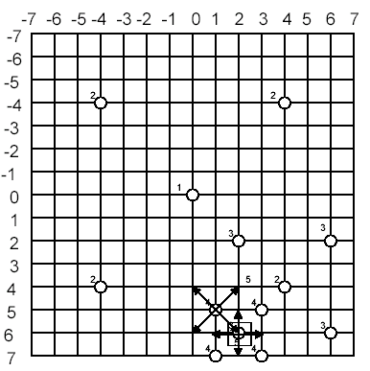

■

5. H.261. (15%) In H.261, the Huffman coding table for the differential motion vectors is shown as follows.
Assuming the motion vector of the previous macroblock is (3, -5) and the motion vector of the current macroblock is (MVx, MVy). The coding of the differential motion vector results in the code (0000110, 00001011). What is the motion vector (MVx, MVy).

<Ans.>
(0000110) => dx = 4 or –28
(00001011)=> dy = -5 or 27

So, MVx = dx + 3 = 7 or –25
MVy = dy - 5 = -10 or 22

Since MVx, MVy are in the range of (-16,16),
We get MV = ( 7, -10 ) ■

6. Complexity Reduction. (20%) DCT and IDCT are linear operations. For example, it can be shown that:
By using the linearity property of DCT/IDCT and observe that a DCT will cancel out an IDCT, show a system which has minimal numbers of DCT/IDCT operations and performs the same function as the system below.
<Ans.>

