線性代數平時考 (Chap 1)
3/23/05 (close book)
學號: 姓名:

- (20%) Given a system of the form
where m₁, m₂, b₁, and b₂ are constants:
  - Show that the system will have a unique solution if (7%)
  - If , show that the system will be consistent only if (7%)
  - Give a geometric interpretation to parts (a) and (b) (6%)
Ans:
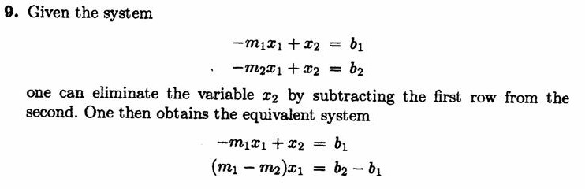
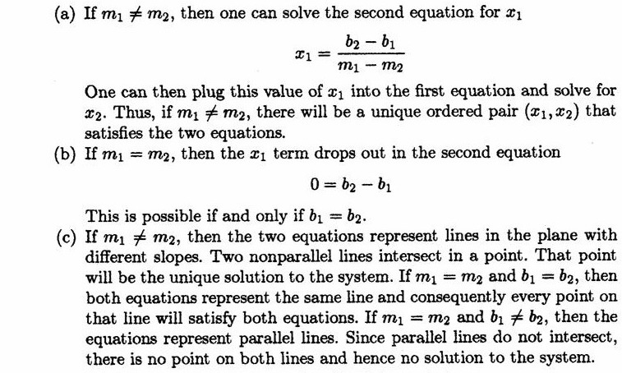

- (20%) Consider a linear system whose augmented matrix is of the form.
(a) For what values of a and b will the system have infinitely many solutions?
(b) For what values of a and b will the system be inconsistent?
Ans:
$$\left[\begin{matrix}1 & 1 & 3 \\ 1 & 2 & 4 \\ 1 & 3 & a\end{matrix}|\begin{matrix}2 \\ 3 \\ b\end{matrix}\right]→\left[\begin{matrix}1 & 1 & 3 \\ 0 & 1 & 1 \\ 0 & 2 & a−3\end{matrix}|\begin{matrix}2 \\ 1 \\ b−2\end{matrix}\right]→\left[\begin{matrix}1 & 1 & 3 \\ 0 & 1 & 1 \\ 0 & 0 & a−5\end{matrix}|\begin{matrix}2 \\ 1 \\ b−4\end{matrix}\right]$$
(a) $a=5,b=4$ infinitely many solutions
(b) $a=5,b≠4$ inconsistent

- (20%) For each of the following choices of A and b, determine whether the system Ax = b is consistent by examine how b relates to the column vectors of A. Explain your answers in each case.
(a) , (10%)
(b) , (10%)
Ans:

- (20%) Compute the LU factorization of the following matrix
Ans:

- (20%) Use elementary row operations to find the inverse of the following matrix
Ans:

